Name: Ehsan Ahmed Shaikh

NED_PGD_DS&AI

Python Assignment1

**Hello World Program by Using Jupyter Notebook**

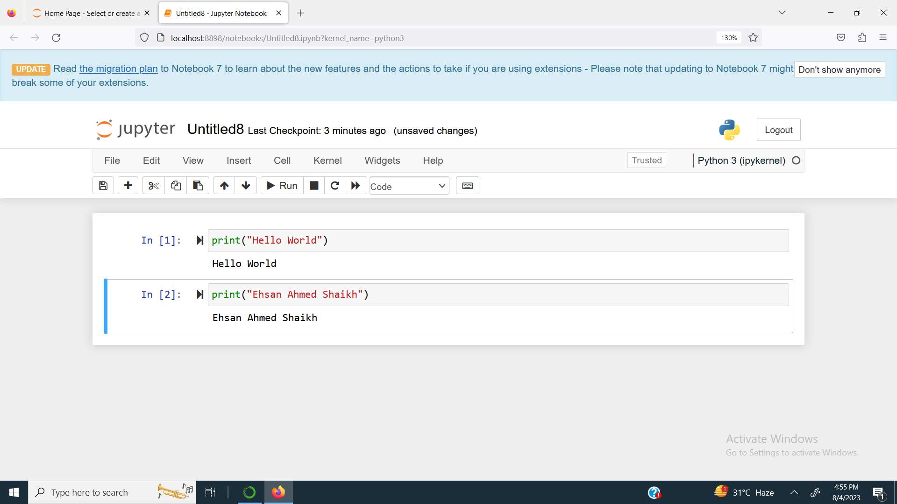

**Hello World Program by Using Jupyter Lab**

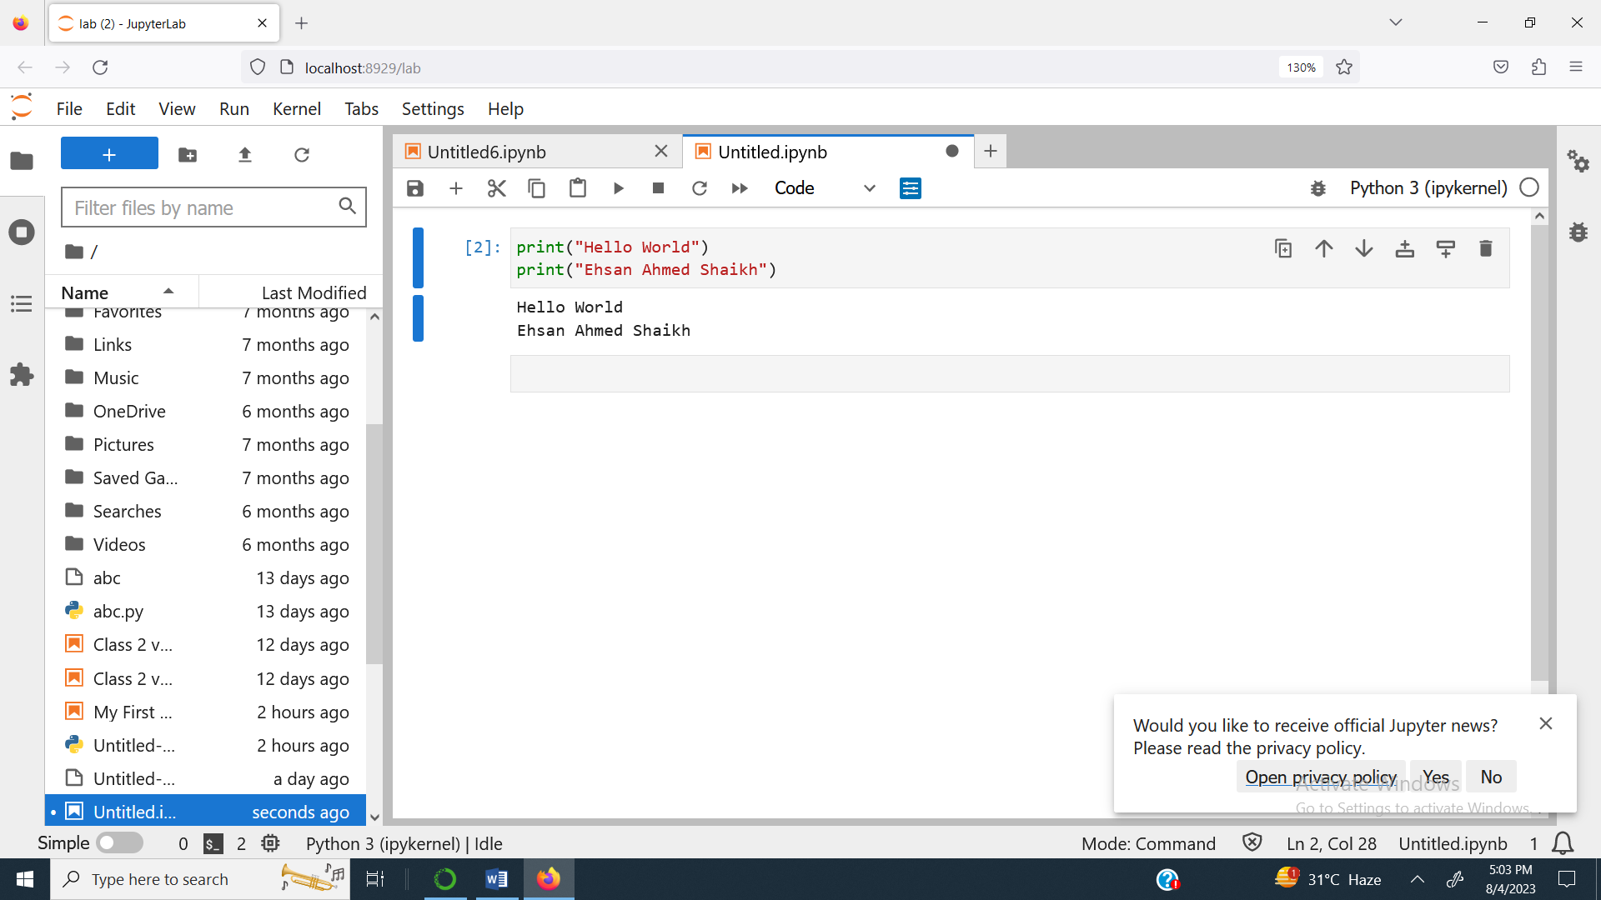

**Hello World Program by Using VS Code**

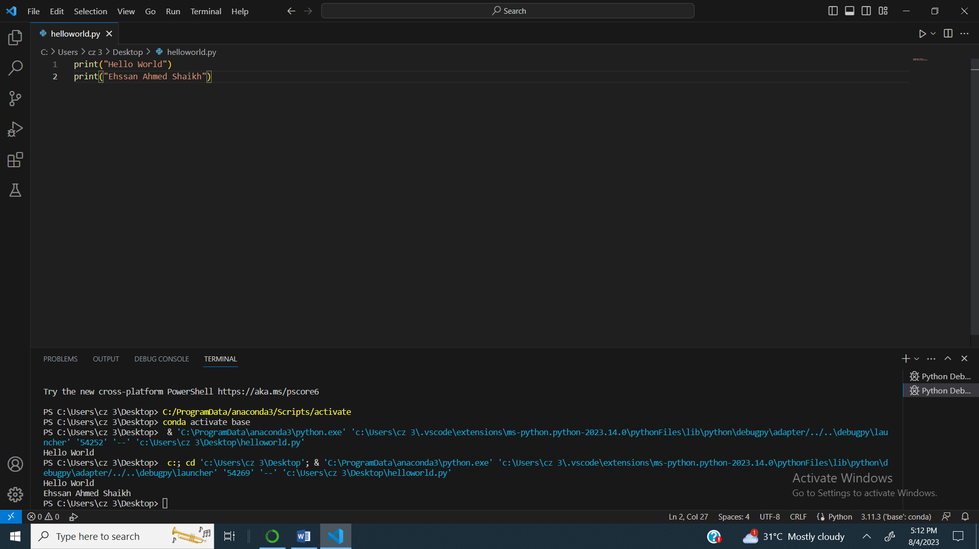

**Hello World Program by Using Command Prompt**

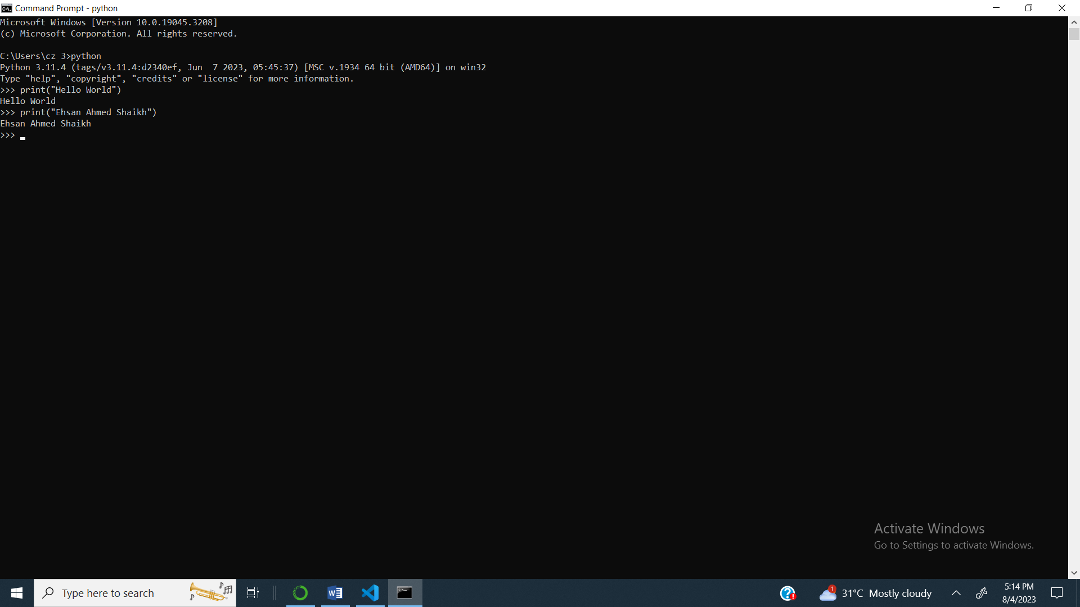

**Hello World Program by Using Google Colab**

